CLOUD COMPUTING
SUBMITTED BY: ARMEEN ABID (BSE-011)
SUBMITTED TO: ENGR.MUHAMMAD SHOAIB
LAB 13
Terraform IAM Management with AWS
TASK 1:

Create IAM Group and Output Details
In this task, you will create an IAM group named "developers" and output its details.
- Create the initial project structure:
mkdir -p ~/Lab13
cd ~/Lab13

- Create the main Terraform file:
touch main.tf
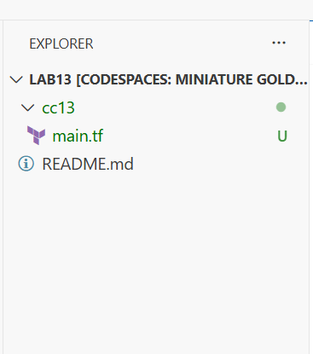
mkdir cc13 && cd cc13
touch main.tf

Create main.tf with AWS provider configuration:
provider "aws" {
shared_config_files = ["~/.aws/config"]
shared_credentials_files = ["~/.aws/credentials"]
}

resource "aws_iam_group" "developers" {
name = "developers"
path = "/groups/"
}

output "group_details" {
value = {
group_name = aws_iam_group.developers.name
group_arn = aws_iam_group.developers.arn
unique_id = aws_iam_group.developers.unique_id
}
}
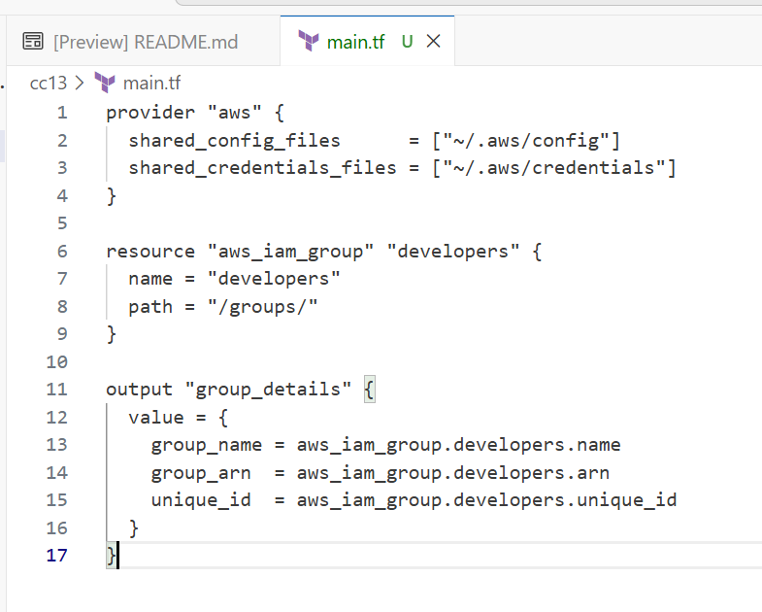
- Initialize Terraform:
terraform init
- Apply the configuration:
terraform apply -auto-approve
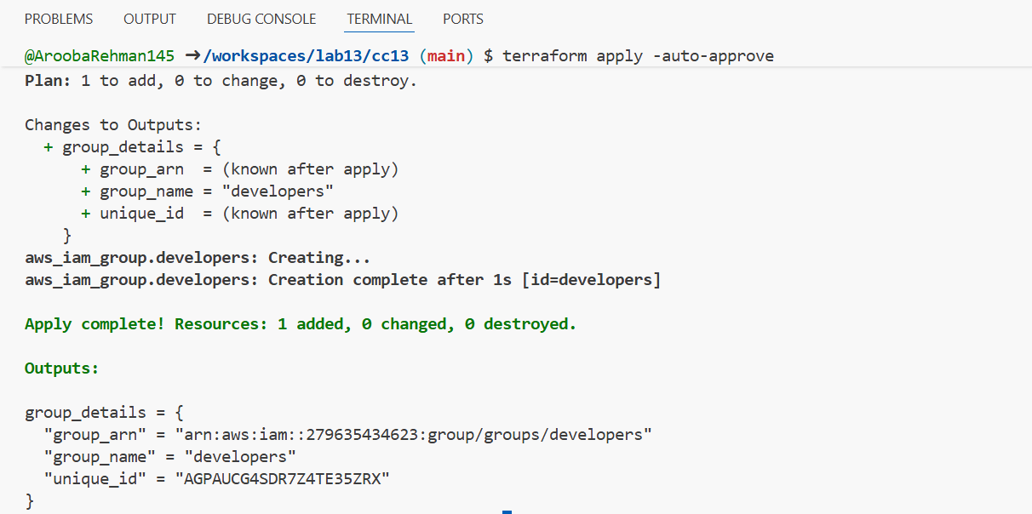
- Display the output:
terraform output
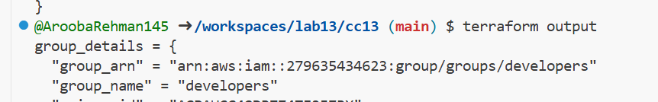
- Verify the group in AWS Console:
- Navigate to IAM → Groups in AWS Console
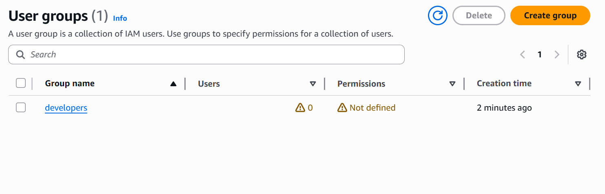
TASK 2:

Create IAM User with Group Membership
In this task, you will create an IAM user named "loadbalancer" and add it to the developers group.
- Update main.tf to add the IAM user resource:
- provider "aws" {
- shared_config_files = ["~/. aws/config"]
- shared_credentials_files = ["~/.aws/credentials"]
- }

- resource "aws_iam_group" "developers" {
- name = "developers"
- path = "/groups/"
- }

- output "group_details" {
- value = {
- group_name = aws_iam_group.developers. name
- group_arn = aws_iam_group. developers.arn
- unique_id = aws_iam_group.developers.unique_id
- }
- }

- resource "aws_iam_user" "lb" {
- name = "loadbalancer"
- path = "/users/"
- force_destroy = true
- tags = {
- DisplayName = "Load Balancer"
- }
- }

- resource "aws_iam_user_group_membership" "lb_membership" {
- user = aws_iam_user.lb.name
- groups = [
- aws_iam_group. developers.name
- ]
- }

- output "user_details" {
- value = {
- user_name = aws_iam_user. lb.name
- user_arn = aws_iam_user.lb.arn
- unique_id = aws_iam_user.lb.unique_id
- }
- }
- Apply the configuration:
terraform apply -auto-approve
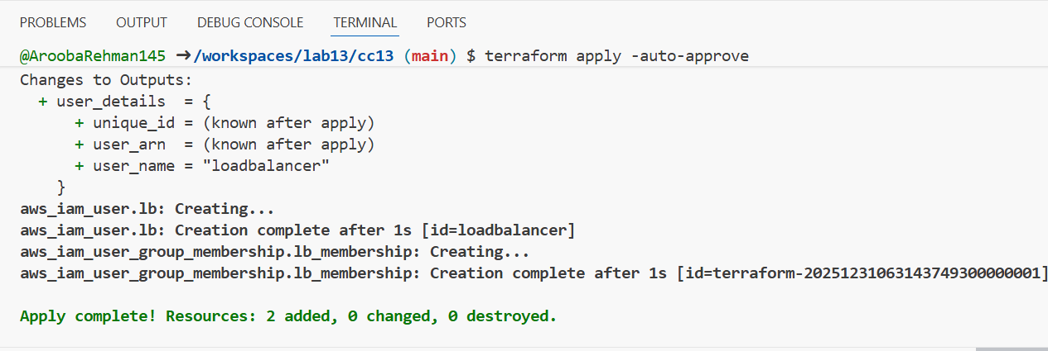

- Display the outputs:
terraform output
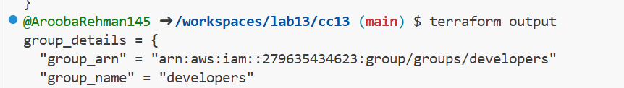
- Verify the user in AWS Console:
- Navigate to IAM → Users in AWS Console
- Click on "loadbalancer" user
- Check the "Groups" tab

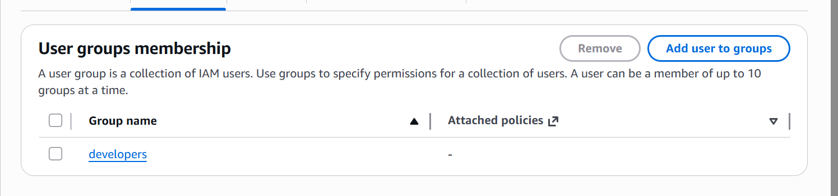

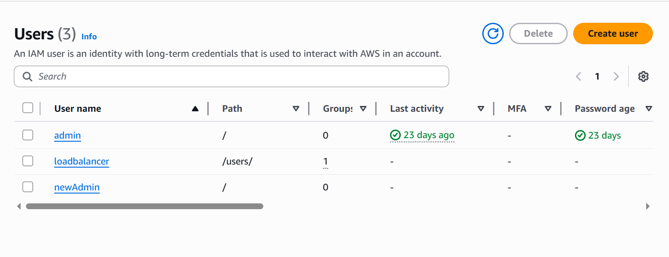

TASK 3:

Attach Policies to IAM Group
In this task, you will attach AWS managed policies (AmazonEC2FullAccess and IAMUserChangePassword) to the developers group.
- Update main.tf to add policy attachments:
provider "aws" {
shared_config_files = ["~/.aws/config"]
shared_credentials_files = ["~/.aws/credentials"]
}

resource "aws_iam_group" "developers" {
name = "developers"
path = "/groups/"
}

output "group_details" {
value = {
group_name = aws_iam_group. developers.name
group_arn = aws_iam_group.developers.arn
unique_id = aws_iam_group.developers.unique_id
}
}

resource "aws_iam_user" "lb" {
name = "loadbalancer"
path = "/users/"
force_destroy = true
tags = {
DisplayName = "Load Balancer"
}
}

resource "aws_iam_user_group_membership" "lb_membership" {
user = aws_iam_user. lb.name
groups = [
aws_iam_group.developers.name
]
}

output "user_details" {
value = {
user_name = aws_iam_user. lb.name
user_arn = aws_iam_user.lb.arn
unique_id = aws_iam_user.lb.unique_id
}
}

resource "aws_iam_group_policy_attachment" "developer_ec2_fullaccess" {
group = aws_iam_group.developers.name
policy_arn = "arn:aws:iam::aws:policy/AmazonEC2FullAccess"
}

resource "aws_iam_group_policy_attachment" "change_password" {
group = aws_iam_group.developers.name
policy_arn = "arn:aws:iam::aws:policy/IAMUserChangePassword"
}
- Apply the configuration:
terraform apply -auto-approve
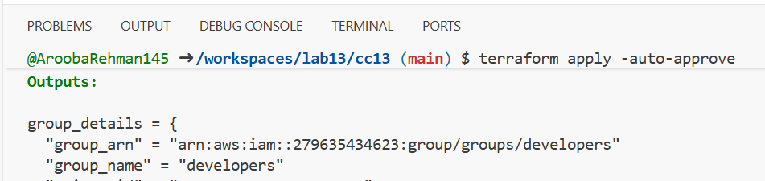
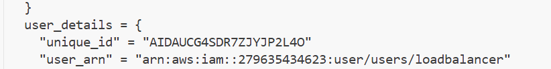
- Verify policies in AWS Console:
- Navigate to IAM → Groups → developers
- Click on "Permissions" tab
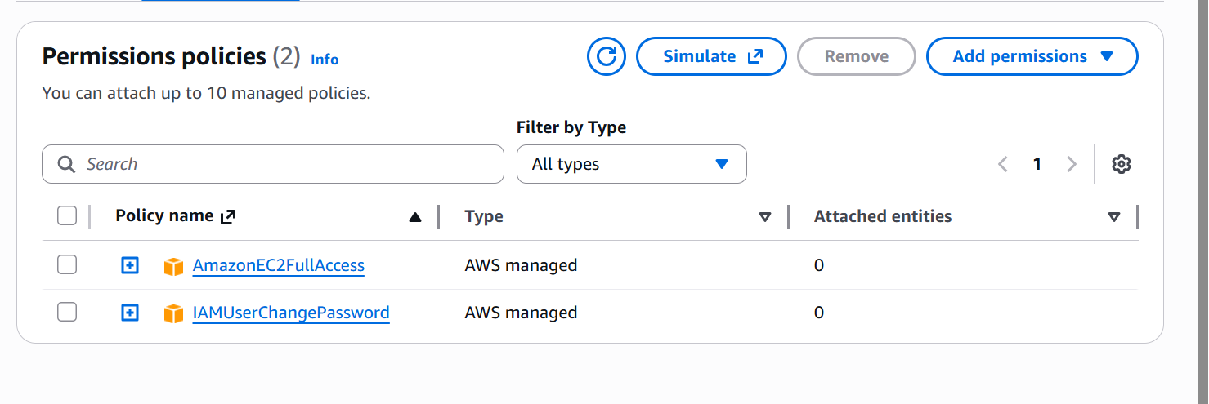

Task 4

Create Login Profile for IAM User
In this task, you will create a login profile for the loadbalancer user using a bash script and null_resource provisioner.
- Create variables.tf file:
variable "iam_password" {
description = "Temporary password for the IAM user"
type = string
sensitive = true
default = "1dontKnow"
}
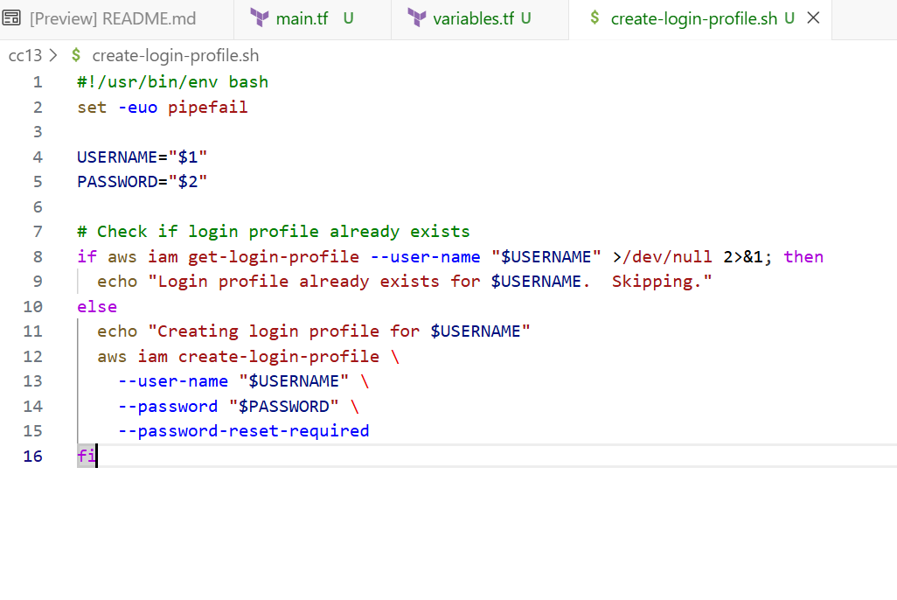
- Create the bash script create-login-profile.sh:
#!/usr/bin/env bash
set -euo pipefail

USERNAME="$1"
PASSWORD="$2"

# Check if login profile already exists
if aws iam get-login-profile --user-name "$USERNAME" >/dev/null 2>&1; then
echo "Login profile already exists for $USERNAME. Skipping."
else
echo "Creating login profile for $USERNAME"
aws iam create-login-profile \
--user-name "$USERNAME" \
--password "$PASSWORD" \
--password-reset-required
fi
- Make the script executable:
chmod +x create-login-profile.sh
- Update main.tf to add the null_resource provisioner:
Add this resource after the user creation:
resource "null_resource" "create_login_profile" {
triggers = {
password_hash = sha256(var.iam_password)
user = aws_iam_user.lb. name
}

depends_on = [aws_iam_user. lb]

provisioner "local-exec" {
command = "${path.module}/create-login-profile.sh ${aws_iam_user.lb.name} '${var.iam_password}'"
}
}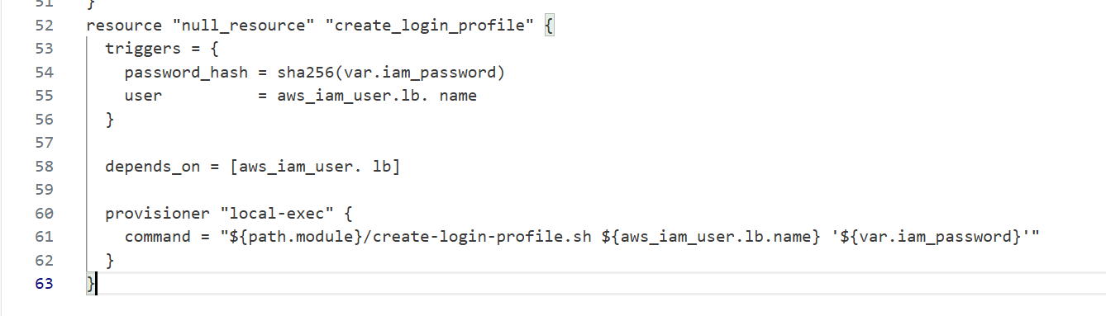
- Apply the configuration with a custom password:
terraform apply -auto-approve -var="iam_password=MySecurePass123!"
terraform init –upgrade
# 1. Download the installer
curl "https://awscli.amazonaws.com/awscli-exe-linux-x86_64.zip" -o "awscliv2.zip"

# 2. Unzip it (Install unzip first if needed)
sudo apt-get install unzip -y
unzip -o awscliv2.zip

# 3. Run the installer
sudo ./aws/install --update
terraform apply -auto-approve -var="iam_password=MySecurePass123!"
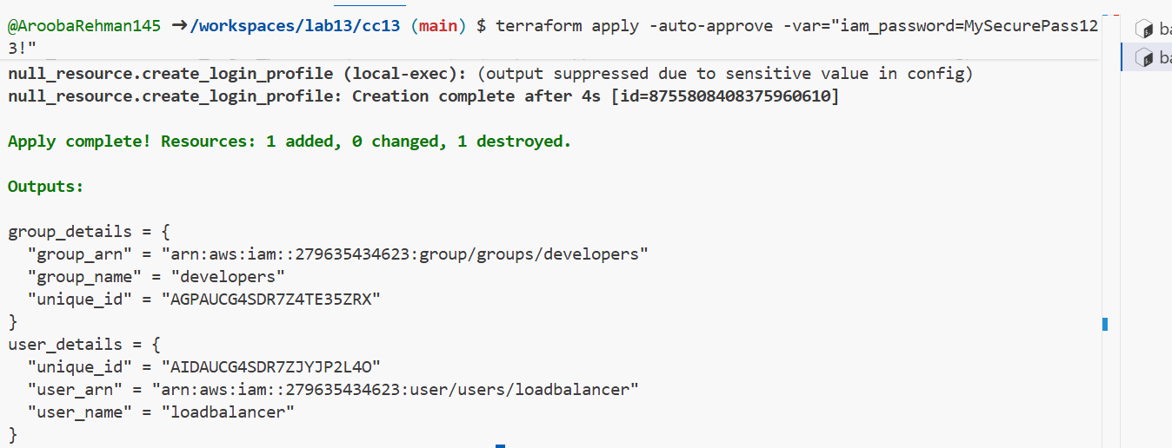

- Verify login profile creation:
aws iam get-login-profile --user-name loadbalancer
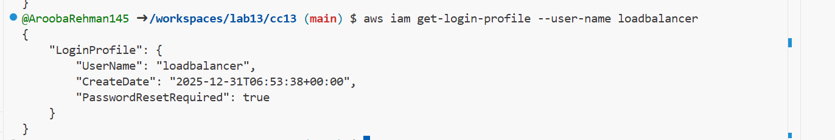
- Test login in AWS Console:
- Open AWS Console login page
- Sign in as IAM user with username "loadbalancer" and the password you set
- You should be prompted to change password
Command for AccountID:
aws sts get-caller-identity --query Account --output text
Username:loadbalancer
Password:MySecurePass123!

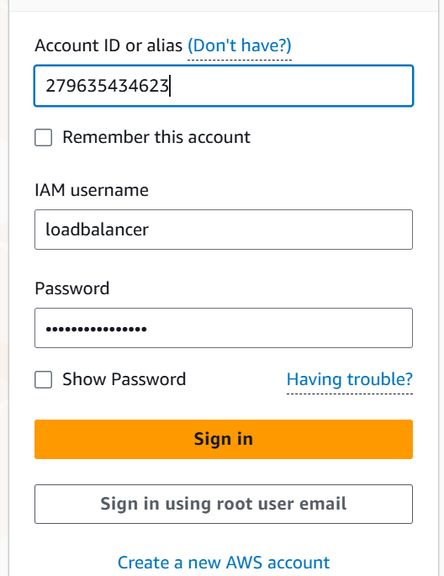
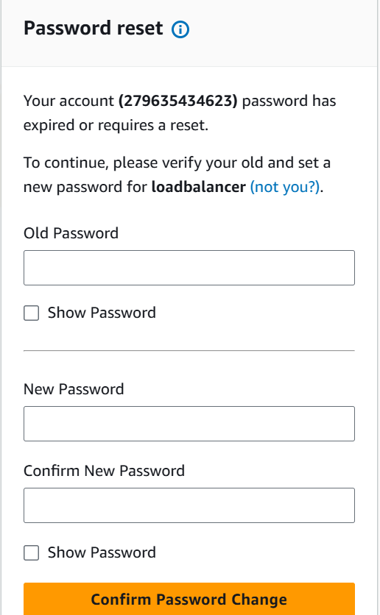

Task 5

Generate Access Keys for IAM User
In this task, you will create access keys for the loadbalancer user and view them in terraform state.
- Update main.tf to add access key resource and outputs:
Add these resources:
resource "aws_iam_access_key" "lb_access_key" {
user = aws_iam_user.lb.name
}

output "access_key_id" {
value = aws_iam_access_key.lb_access_key.id
}

output "access_key_secret" {
value = aws_iam_access_key.lb_access_key. secret
sensitive = true
}
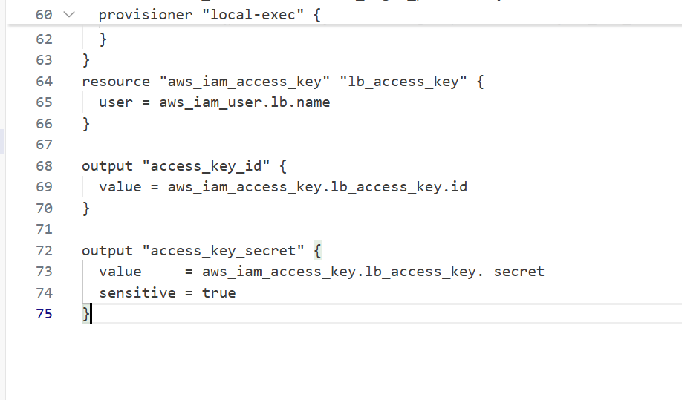
- Apply the configuration:
terraform apply -auto-approve -var="iam_password=MySecurePass123!"
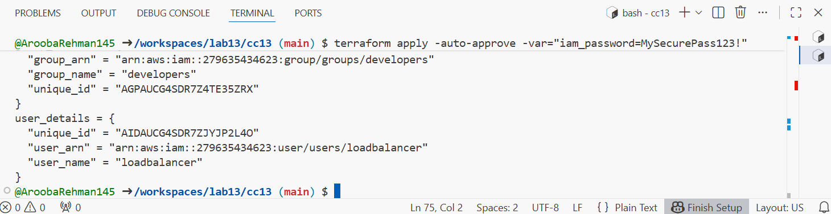
- Display outputs:
terraform output
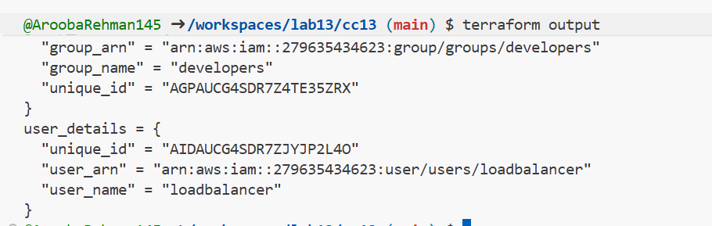
- View the secret in terraform state:
cat terraform.tfstate | grep -A 10 "access_key_secret"
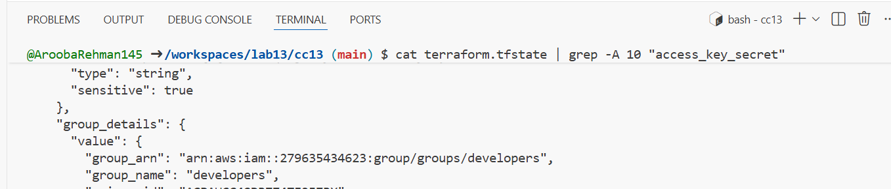
- Verify access key in AWS Console:
- Navigate to IAM → Users → loadbalancer → Security credentials
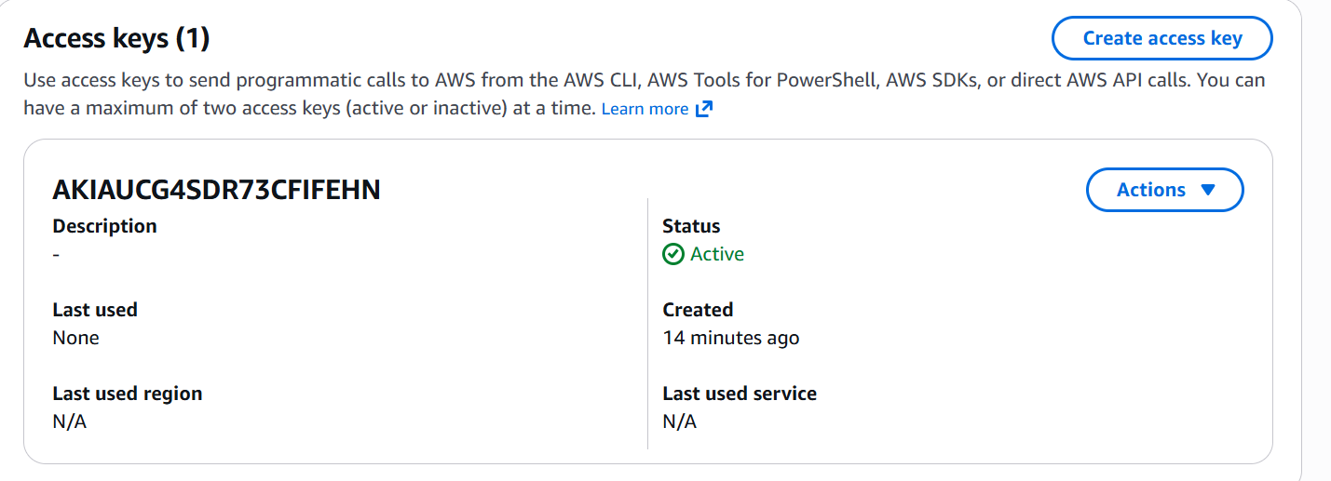

Task 6

Implement Terraform Remote State with S3
In this task, you will configure Terraform to use S3 backend for remote state storage.
- Create S3 bucket in AWS Console:
- Navigate to S3 in AWS Console
- Click "Create bucket"
- Bucket name: myapp-s3-bucket-demo (use a unique name if this is taken)
- Enable versioning
- Keep other settings as default
- Click "Create bucket"
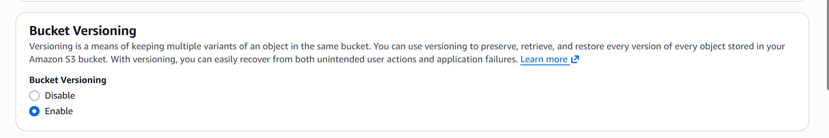

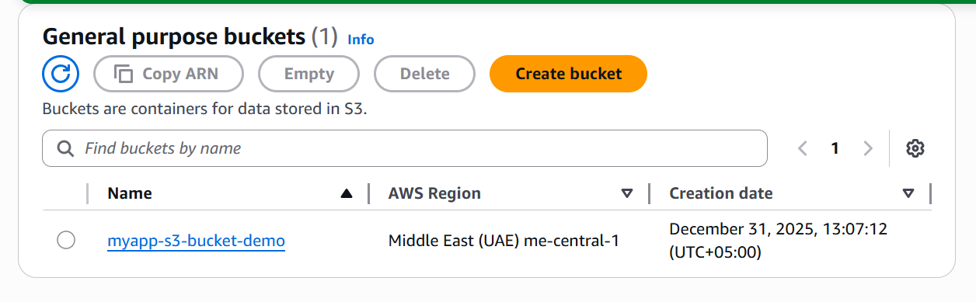
- Update main.tf to add S3 backend configuration:
Add this at the beginning of main.tf (before the provider block):
terraform {
backend "s3" {
bucket = "myapp-s3-bucket-demo"
key = "myapp/terraform.tfstate"
region = "me-central-1"
encrypt = true
use_lockfile = true
}
}
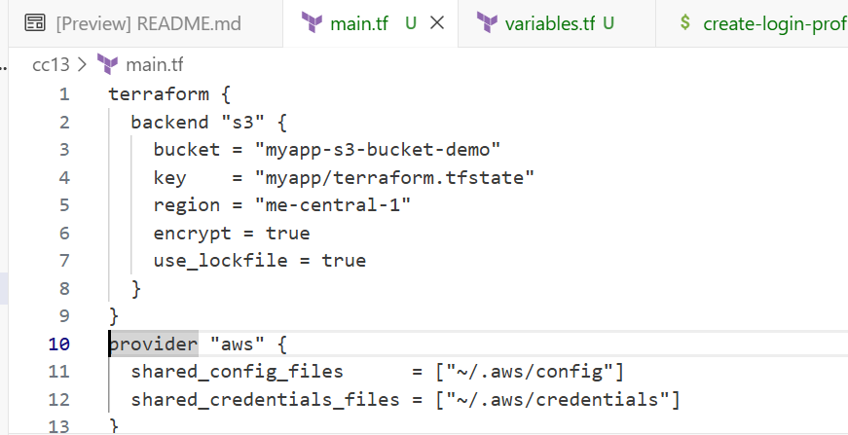
- Reinitialize Terraform with the backend:
terraform init -migrate-state
- Type yes when prompted to migrate state
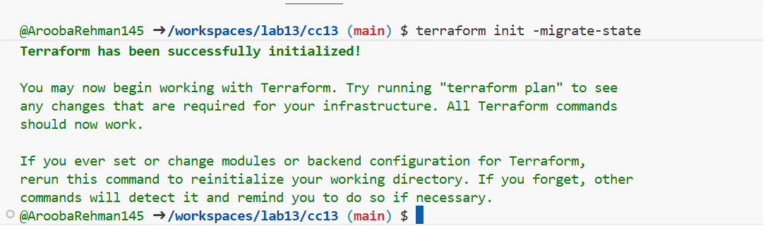
- Apply the configuration:
terraform apply -auto-approve -var="iam_password=MySecurePass123!"

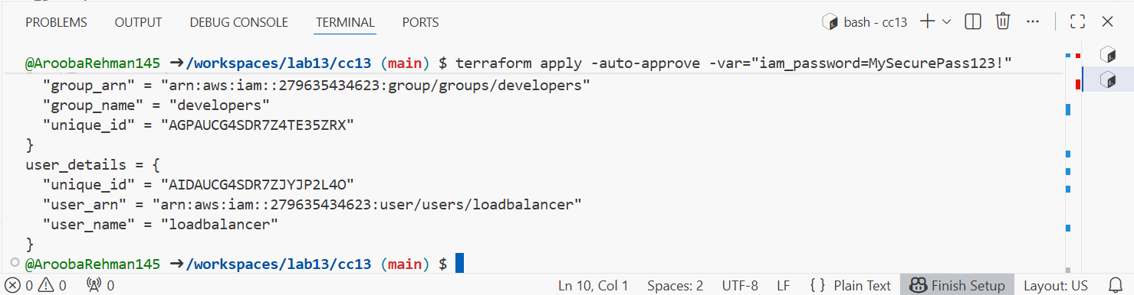
- Verify state file in S3:
- Navigate to S3 → myapp-s3-bucket-demo → myapp/
- You should see terraform.tfstate file
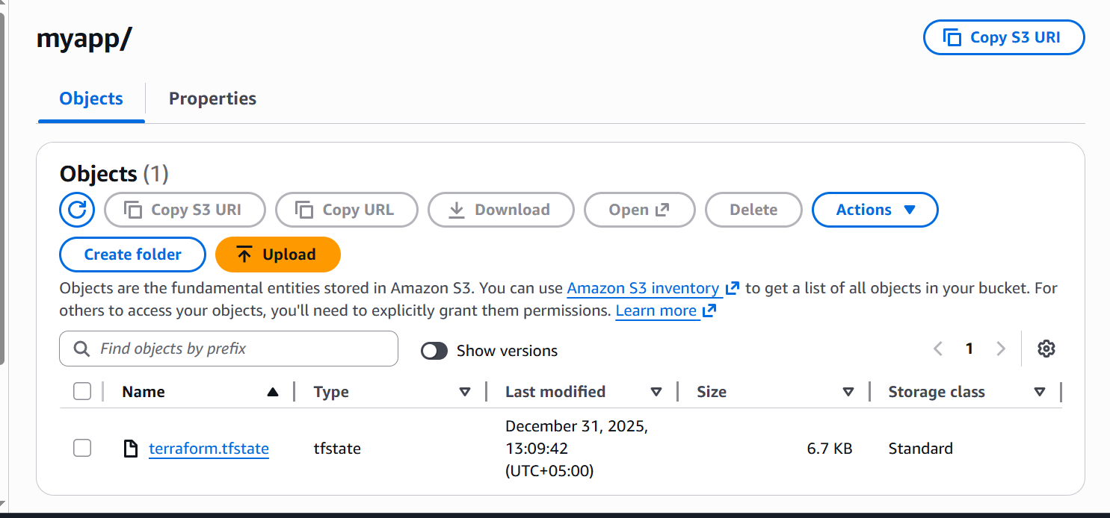
- Check local state file:
ls -la terraform.tfstate*
- Destroy resources and verify state change:
terraform destroy -auto-approve
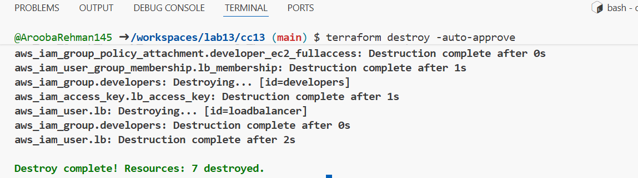
- Verify updated state in S3:
- Refresh S3 bucket view
- Check the terraform.tfstate file (it should show empty resources)
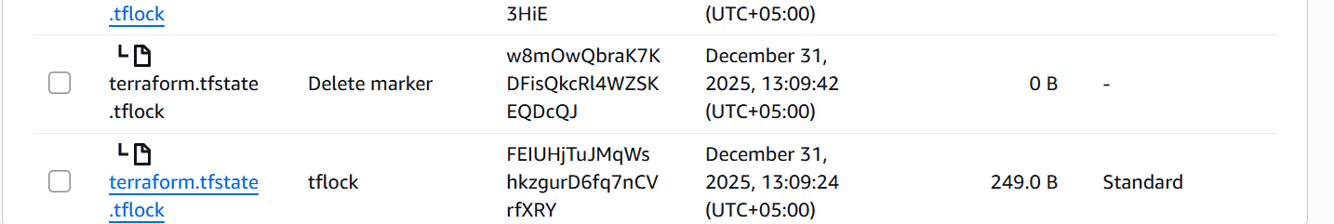

Task 7

Create Multiple Users from CSV File
In this task, you will create multiple IAM users dynamically from a CSV file.
- Create locals.tf file:
locals {
users = csvdecode(file("users.csv"))
}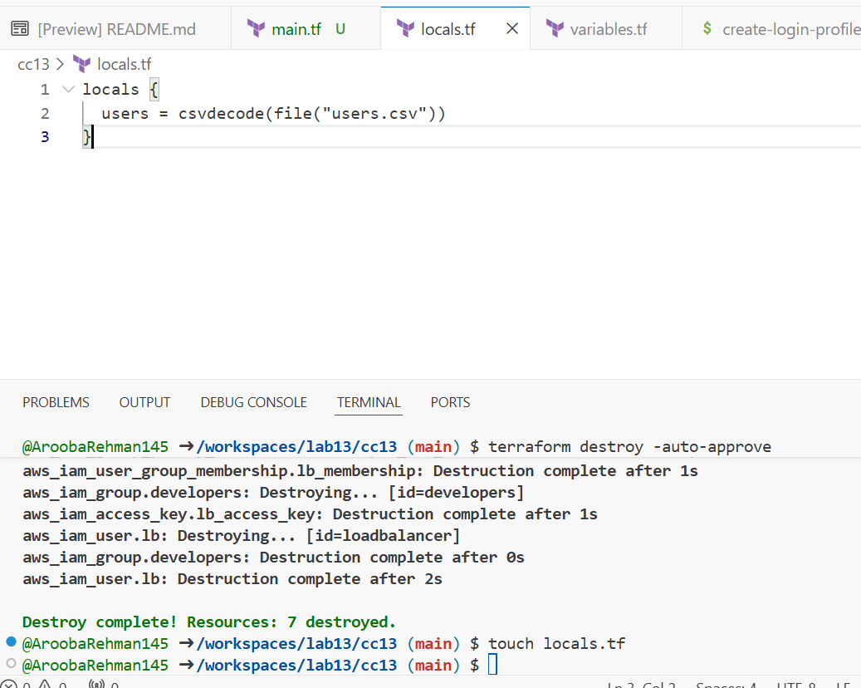
- Create users.csv file:
user_name
Michael
Dwight
Jim
Pam
Ryan
Andy
Robert
Stanley
Kevin
Angela
Oscar
Phyllis
Toby
Kelly
Darryl
Creed
Meredith
Erin
Gabe
Jan
David
Holly
Charles
Jo
Clark
Peter
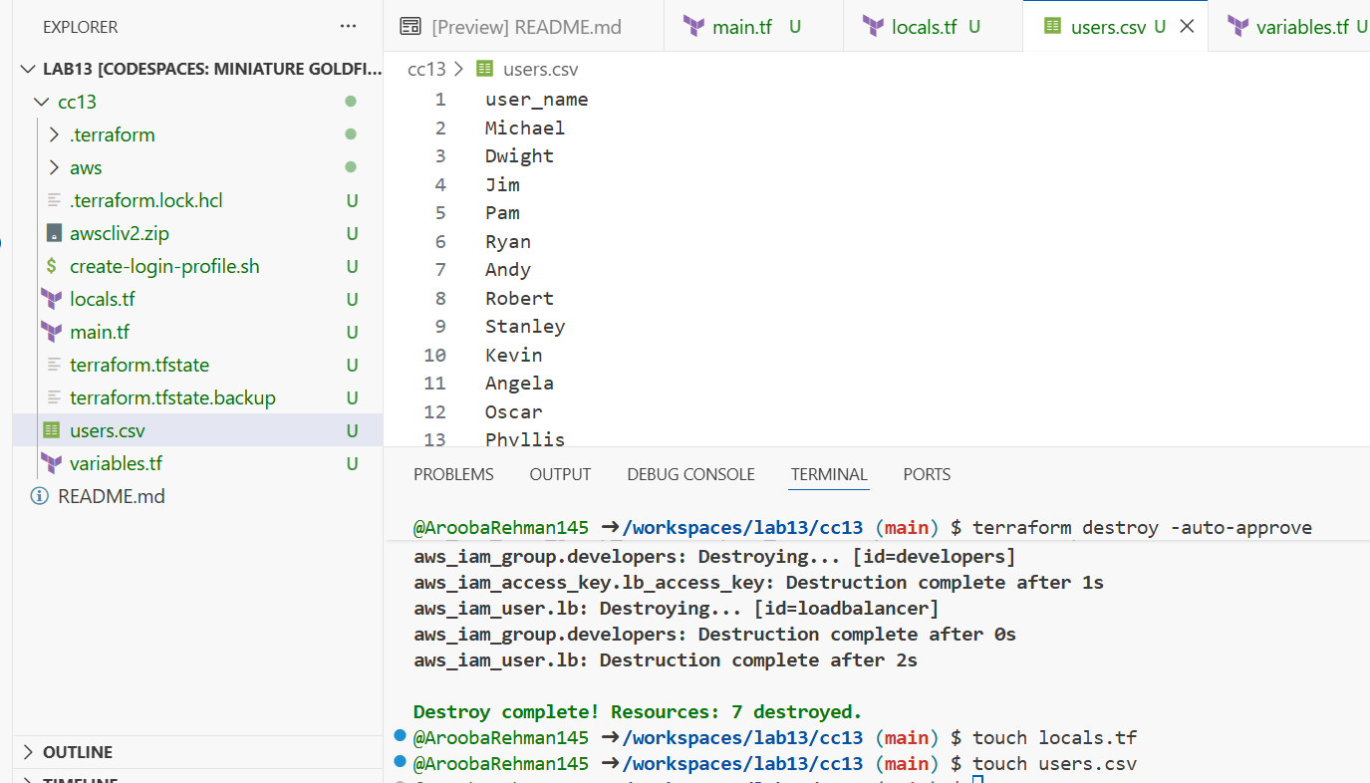
- Update main.tf to create multiple users:
Replace the single user resources with:
# Create multiple IAM users from CSV
resource "aws_iam_user" "users" {
for_each = { for user in local.users : user.user_name => user }

name = each.value.user_name
path = "/users/"
force_destroy = true

tags = {
DisplayName = each.value.user_name
CreatedBy = "Terraform"
}
}

# Add all users to developers group
resource "aws_iam_user_group_membership" "users_membership" {
for_each = aws_iam_user.users

user = each.value.name
groups = [
aws_iam_group.developers. name
]
}

# Create login profiles for all users
resource "null_resource" "create_login_profiles" {
for_each = aws_iam_user.users

triggers = {
password_hash = sha256(var. iam_password)
user = each.value.name
}

depends_on = [aws_iam_user. users]

provisioner "local-exec" {
command = "${path. module}/create-login-profile. sh ${each.value.name} '${var.iam_password}'"
}
}

# Create access keys for all users
resource "aws_iam_access_key" "users_access_keys" {
for_each = aws_iam_user. users

user = each.value.name
}

# Output all user details
output "all_users_details" {
value = {
for user_name, user in aws_iam_user.users : user_name => {
user_arn = user.arn
user_unique_id = user.unique_id
access_key_id = aws_iam_access_key.users_access_keys[user_name].id
}
}
}

# Output all access key secrets (sensitive)
output "all_access_key_secrets" {
value = {
for user_name, key in aws_iam_access_key.users_access_keys : user_name => key.secret
}
sensitive = true
}
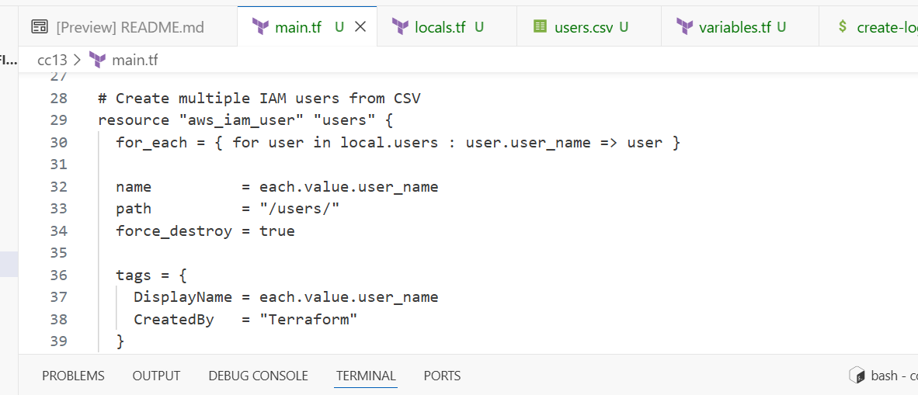
- Reinitialize Terraform (since we changed the configuration significantly):
terraform init
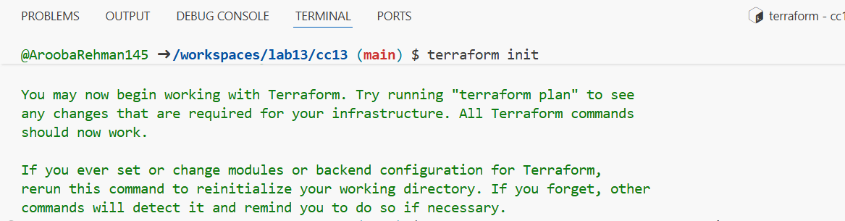
- Apply the configuration to create all users:
terraform apply -auto-approve -var="iam_password=MySecurePass123!"
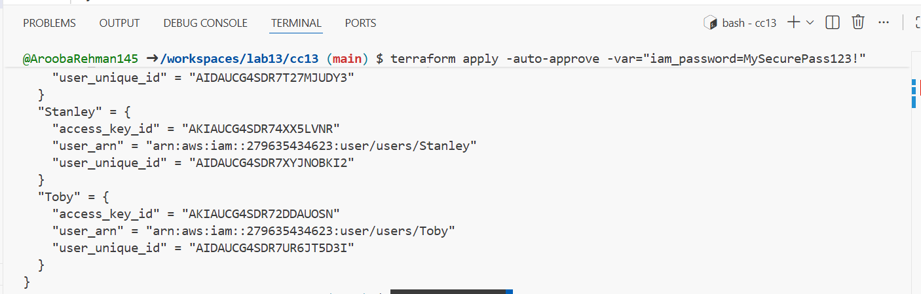
- Display the outputs:
terraform output
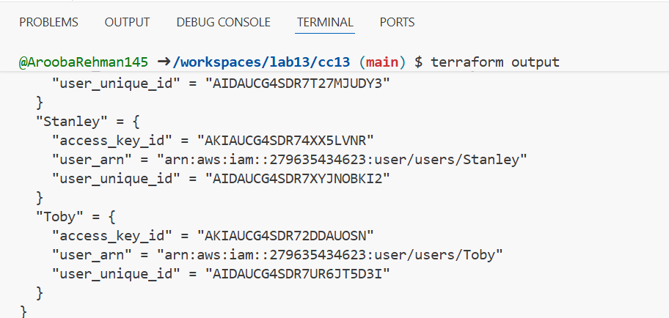
- View secrets in terraform. tfstate:
cat terraform.tfstate | grep -A 5 "all_access_key_secrets"
- Verify all users in AWS Console:
- Navigate to IAM → Users
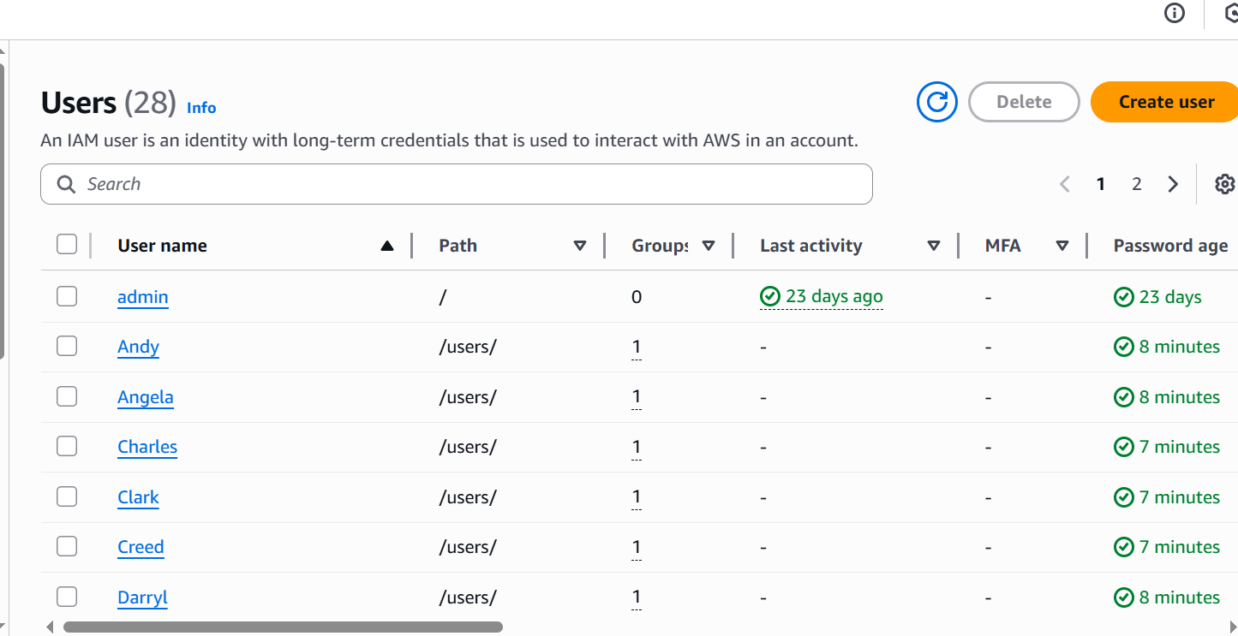
- Verify group membership:
- Navigate to IAM → Groups → developers → Users tab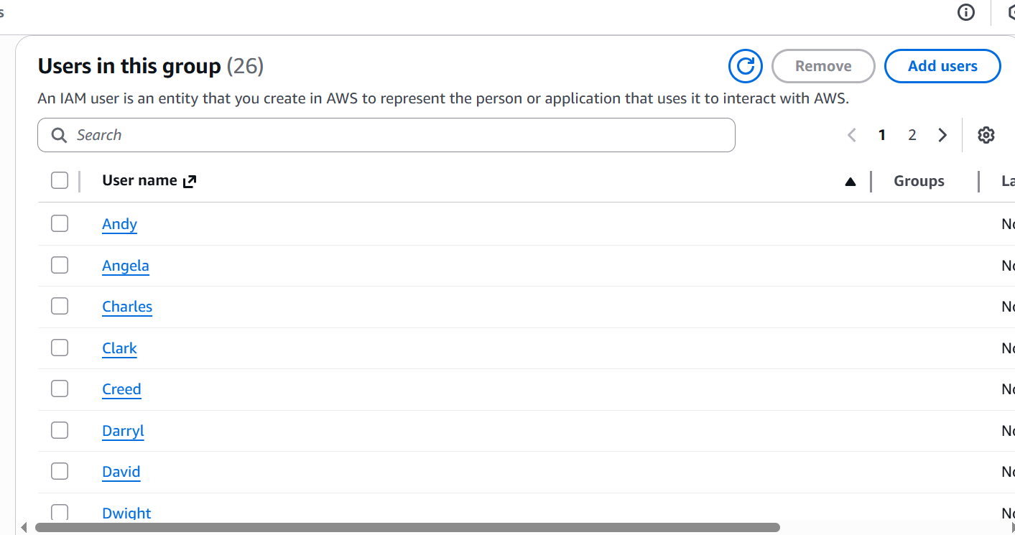
- Verify one user's access keys:
- Click on any user (e.g., "Michael")
- Go to Security credentials tab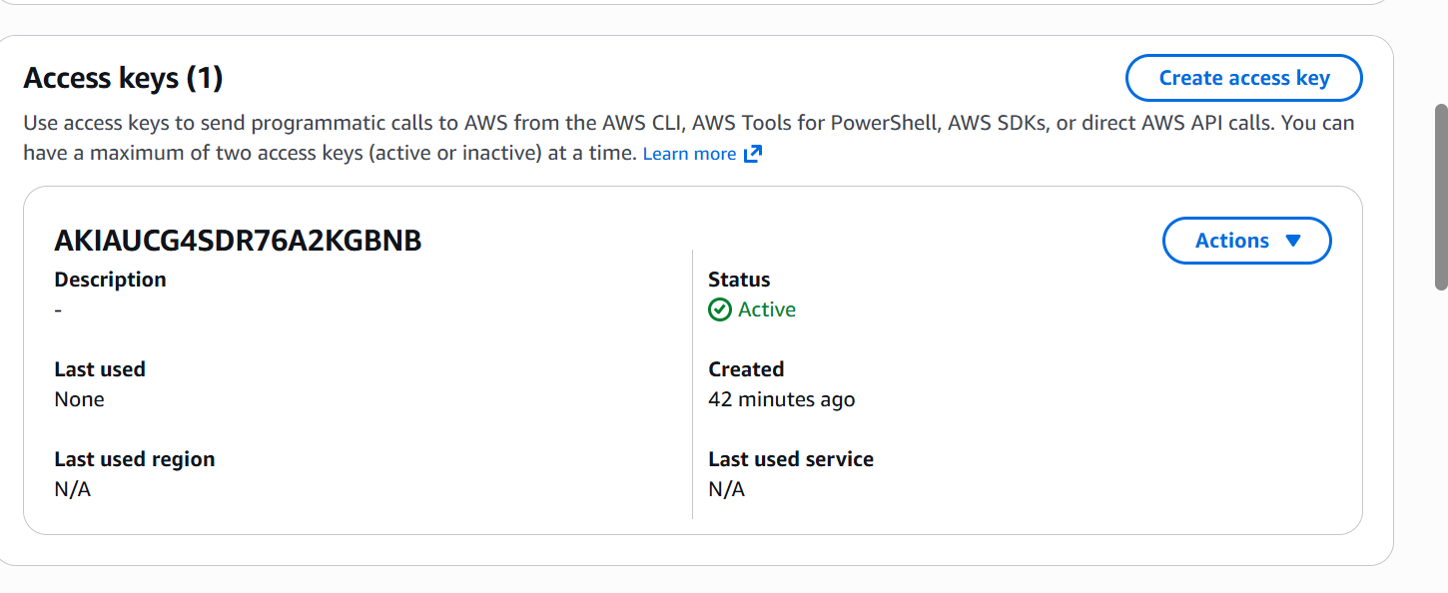
- Check terraform state in S3:
- Navigate to S3 bucket and view the state file

Cleanup
- Destroy all resources:
terraform destroy -auto-approve

